Name :-Kunal R Agarwal

SRN No:-201700110

Roll No:-18

Question:-Implement K means Clustering

**Input:-**

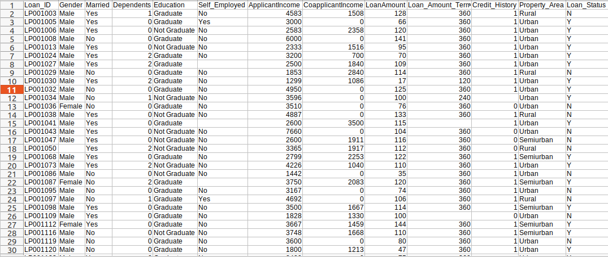

**Code:-**

import pandas as pd

import numpy as np

import random as rd

import matplotlib.pyplot as plt

data = pd.read_csv('../input/clusteringforsalary/clustering.csv')

data.head()

X = data[["LoanAmount","ApplicantIncome"]]

plt.scatter(X["ApplicantIncome"],X["LoanAmount"],c='black')

plt.xlabel('AnnualIncome')

plt.ylabel('Loan Amount (In Thousands)')

plt.show()

K=3

Centroids = (X.sample(n=K))

plt.scatter(X["ApplicantIncome"],X["LoanAmount"],c='black')

plt.scatter(Centroids["ApplicantIncome"],Centroids["LoanAmount"],c='red')

plt.xlabel('AnnualIncome')

plt.ylabel('Loan Amount (In Thousands)')

plt.show()

diff = 1

j=0

while(diff!=0):

XD=X

i=1

for index1,row_c in Centroids.iterrows():

ED=[]

for index2,row_d in XD.iterrows():

d1=(row_c["ApplicantIncome"]-row_d["ApplicantIncome"])**2

d2=(row_c["LoanAmount"]-row_d["LoanAmount"])**2

d=np.sqrt(d1+d2)

ED.append(d)

X[i]=ED

i=i+1

C=[]

for index,row in X.iterrows():

min_dist=row[1]

pos=1

for i in range(K):

if row[i+1] < min_dist:

min_dist = row[i+1]

pos=i+1

C.append(pos)

X["Cluster"]=C

Centroids_new = X.groupby(["Cluster"]).mean()[["LoanAmount","ApplicantIncome"]]

if j == 0:

diff=1

j=j+1

else:

diff = (Centroids_new['LoanAmount'] - Centroids['LoanAmount']).sum() + (Centroids_new['ApplicantIncome'] - Centroids['ApplicantIncome']).sum()

print(diff.sum())

Centroids = X.groupby(["Cluster"]).mean()[["LoanAmount","ApplicantIncome"]]

color=['blue','green','cyan']

for k in range(K):

data=X[X["Cluster"]==k+1]

plt.scatter(data["ApplicantIncome"],data["LoanAmount"],c=color[k])

plt.scatter(Centroids["ApplicantIncome"],Centroids["LoanAmount"],c='red')

plt.xlabel('Income')

plt.ylabel('Loan Amount (In Thousands)')

plt.show()

**Output:-**

